**Types of Diodes and Their Applications**

**Various Types of Diodes With Their Characteristics & Uses**

The diode is the most used semiconductor device in electronics circuits. It is a two-terminal electrical check valve that allows the flow of current in one direction. They are mostly made up of silicon but germanium is also used. Usually, they are used for rectification. But there are different properties & characteristics of diodes which can be used for different application. These characteristics are modified to form different types of diodes. Nowadays, several different types of diodes having different properties are available.

**P-N Junction Diode**

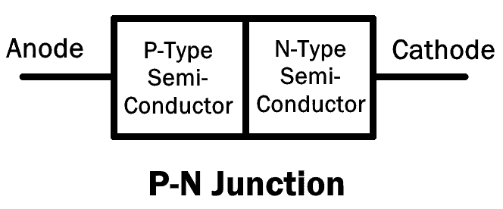The P-N junction diode is made up of semiconductor material. It consists of two layers of semiconductors. One layer is doped with P-type material and the other layer with N-type material. The combination of these both P and N-type layers form a junction known as the P-N junction. Hence the name P-N junction diode.

It allows the flow of current in the forward direction and blocks it in reverse direction. They are also known as rectifier diode used for rectification.

There are different types of diodes that use the P-N junction with variation in doping concentration.

**Small Signal Diode**

It is a type of P-N junction diode which operates on low voltage signals. Its junction area is very small. Due to which, the junction has less capacitance & low charge storing capacity. It enables the small signal diode to have high switching speed with very fast recovery time. However, its limitations are low voltage and current parameters.

Due to its high switching speed, these types of diodes are used in circuits with high frequencies.

**Rectifier Diode**

A rectifier diode is a type of P-N junction diode, whose P-N junction area is very large. This results in high capacitance in reverse direction. It has low switching speed.

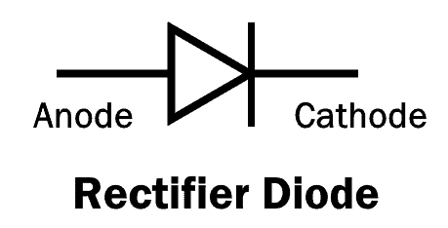

This is the most common and most used type of a diode. These types of diodes can handle heavy current and are used in converting AC into DC (Rectification).

**Schottky Diode**

The Schottky diode, named after a German physicist Walter H. Schottky, is a type of diode which consists of a small junction between an N-type semiconductor and a metal. It has no P-N junction.

The plus point of the Schottky diode is that it has very low forward voltage drop and fast switching. As there is no capacitive junction (P-N junction), the Schottky diode switching speed is very fast.

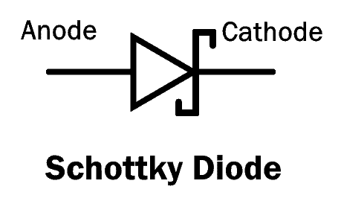

The limitation of Schottky diode is that it has low reverse breakdown voltage and high reverse leakage current.

**Super Barrier Diodes**

Super barrier diodes (SBR) are also rectifier diodes but they have a low forward voltage drop just like a Schottky diode. They have low reverse leakage current just like a normal P-N junction diode.

SBR uses MOSFET by making short contact between its gate and source.

SBR has a low forward voltage drop, less reverse leakage current and fast switching capability.

**Light Emitting Diode (LED)**

The light emitting diode is also a type of P-N junction diode that emits light in the forward bias configuration.

LED is made up of a direct-band semiconductor. When the charge carriers (electrons) cross the barrier and recombine with electron holes on the other side, they emit photon particles (light). While the color of the light depends on the energy gap of the semiconductor.

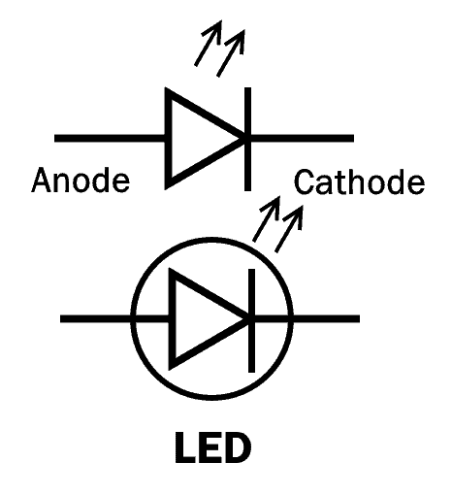

LED converts electrical energy into light energy.

**Photodiode**

The photodiode is a type of P-N junction diode that converts the light energy into electrical current. Its operation is opposite to that of an LED.

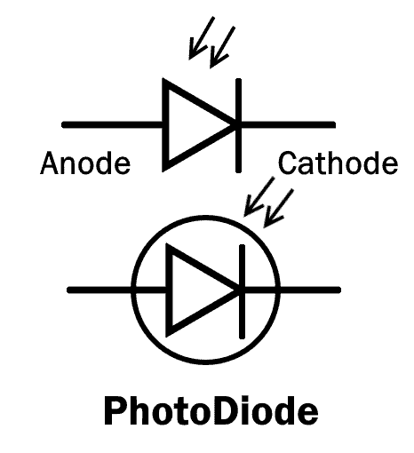

Every semiconductor diode is affected by optical charge carriers. It is why they are packaged in a light blocking material.

In the photodiode, there is a special opening that allows the light to enter its sensitive part.

When the light (Photon particles) strikes the PN junction, it creates an electron-hole pair. These electron and hole flow out as electrical current. To increase its efficiency, a PIN junction diode is used.

A photodiode is used in reverse bias and they can be used in solar cells.

**Laser Diode**

A laser diode is similar to LED because it converts electrical energy into light energy. But unlike LED, Laser diode produces coherent light.

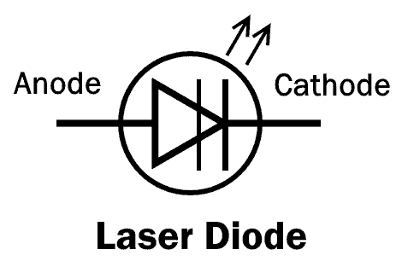

The laser diode consists of a PIN junction, where electron and holes combine together in the intrinsic (I) region. when they combine, it generates a laser beam.

Laser diodes are used in optical communication, laser pointer, CD drives and laser printer etc.

**Tunnel Diode**

Tunnel diode was invented by Leo Esaki in 1958 for which he received Nobel prize in 1973, which is why it is also known as Esaki diode.

A tunnel diode is a heavily doped P-N junction diode. It works on the principle of the tunneling effect. Due to heavy doping concentration, the junction barrier becomes very thin. This allows the electron to easily escape through the barrier. This phenomenon is known as tunneling effect.

The Tunnel diode has a region in its VI curve where the current decreases as the voltage increases. This region is known as the negative resistance region. The tunnel diode operates in this region in different applications such as an oscillator and a microwave amplifier.

The symbol with VI characteristic curve of tunnel diode is given below:

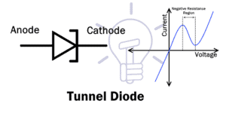

The tunnel diode also conducts current in reverse direction & it is a fast switching device.

**Zener Diode**

Zener diode is named after Clarence Malvin Zener who discovered the zener effect.

It is a type of diode, which not only allows the flow of current in the forward direction but also in reverse direction. when the reverse voltage reaches the breakdown voltage known as Zener voltage it allows the current flow.

The Zener diode has heavier doping concentration than a normal P-N junction diode. Hence, it has a very thin depletion region.

In forward bias, it operates as a simple P-N junction diode (Rectifier).

In reverse bias, it blocks until the reverse voltage reaches breakdown. After that, it allows the current flow with a constant voltage drop.

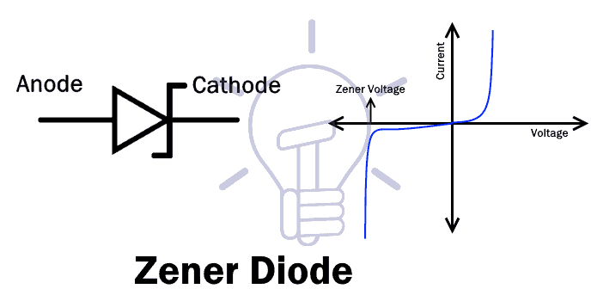

Zener reverse breakdown is caused due to two reason i.e. electron quantum tunneling and Avalanche breakdown.

A Zener diode is mainly used in reverse bias configuration. It provides a stabilized voltage for protection of circuits from overvoltage.

**Backward Diode**

The backward diode or the back diode is a P-N junction diode, whose operation is similar to that of tunnel diode and Zener diode. But the operating voltages are much lower.

A backward diode is essentially a tunnel diode, whose one side of the junction has relatively less doping concentration compared to the other side.

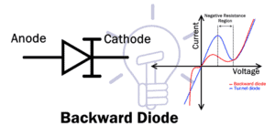

In the forward bias, it operates as a tunnel diode but its tunneling effect is much reduced as compared to tunnel diode. Otherwise, it operates as a normal P-N junction diode.

In reverse bias, it operates as a Zener diode but the breakdown voltages are much lower.

It is not widely used but it can be used for rectification of a small voltage signal (0.1 to 0.6v). Due to its fast switching speed, it can be used as a switch in RF mixer and multiplier.

**Avalanche Diode**

The Avalanche diode is a P-N junction diode that is specifically designed to operate in the avalanche breakdown region.

Avalanche breakdown is a phenomenon where sufficient reverse voltage is applied to the P-N junction. Due to which, the minority carrier ionizes & starts a heavy current flow in reverse direction.

Avalanche diode works electrically similar to the Zener diode. However, the doping concentration of a Zener diode is relatively higher as compared to an avalanche diode.

The heavy doping inside the Zener diode creates a small junction & low voltages can easily break it. However, the avalanche diode has a wide junction because of light doping concentration. Thus, it requires a high voltage for its breakdown. This wide junction makes it a better surge protector compare to a simple Zener diode.

**Transient Voltage Suppression (TVS) Diode**

Transient voltage suppression diode or TVS diode is a type of avalanche diode that protects the circuit form high voltage surges.

TVS diode has the capability of handling high voltages as compared to avalanche diode.

Unidirectional TVS diode operates similar to avalanche diode. it acts as a rectifier in forward bias & surge protector in reverse bias.

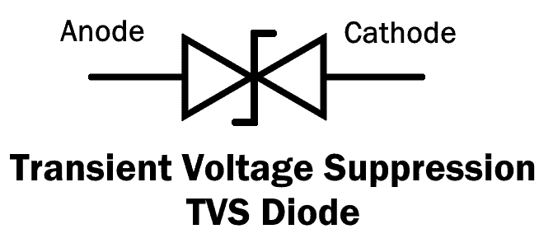

Bidirectional TVS diode acts as two avalanche diodes opposing each other in series. It is manufactured as a single component. It operates both ways and provides surge protection when used in parallel with a circuit.

**Gold Doped Diode**

In such type of diode, Gold or platinum is used as the dopant (doping material). It enables the diode to operate at fast switching speed but at the expense of increasing the forward voltage drop. Also, its reverse leakage current is higher than a normal P-N junction diode.

**Constant Current Diode**

The constant current diode AKA the current-limiting diode (CLD) is a two terminal diode made from JFET. It regulates the current flow through it up to a fixed level.

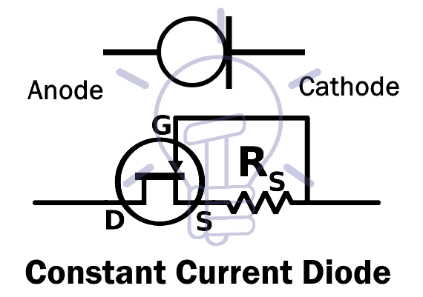

CLD is made by making short contact between the gate and the source of JFET. It limits the current just like Zener diode limits voltage.

**Step Recovery Diode**

Step recovery diode or snap-off diode is a P-N junction diode which abruptly ceases the flow of current when its direction is reversed.

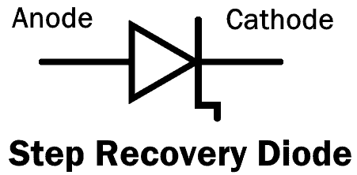

The SRD (Step Recovery Diode) is made of a P-N junction with very low doping concentration near the junction. Due to which, the charge carriers (electron and holes) near the junction also decrease in number. Hence, the charge storing capacity near the junction becomes negligible. This enables the SRD to switch from ON to OFF very fast.

In a normal diode, when it is switched from forward conduction to reverse cutoff, the current flows briefly because of the stored charge. Due to which, the normal diode takes some time in switching. The SRD does not store charge, So it can cease the current flow instantaneously.

**Peltier Or Thermal Diode**

Peltier or thermal diode is a type of diode whose thermal resistance is different in one direction than the other direction. So the heat generated flows in one direction to one side (terminal) and leaving the other side cooler.

This diode is used in the application of heat monitoring in microprocessor and in refrigerators for cooling effect.

**Varactor Diode**

Varactor diode also known as Vericap diode are voltage controlled capacitors. They have a P-N junction with variable junction capacitance.

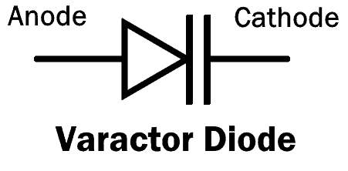

The varactor diode operates under reverse bias conditions. The depletion layer between the P and N-type material is varied by changing the reverse voltage.

All diode’s junction capacitance varies with reverse voltage but Varactor diode is able to use this effect with a high range of capacitance.

The applications of Varactor diodes are as a voltage controlled oscillator in the phase-lock loop, in RF tuning filters and frequency multipliers.